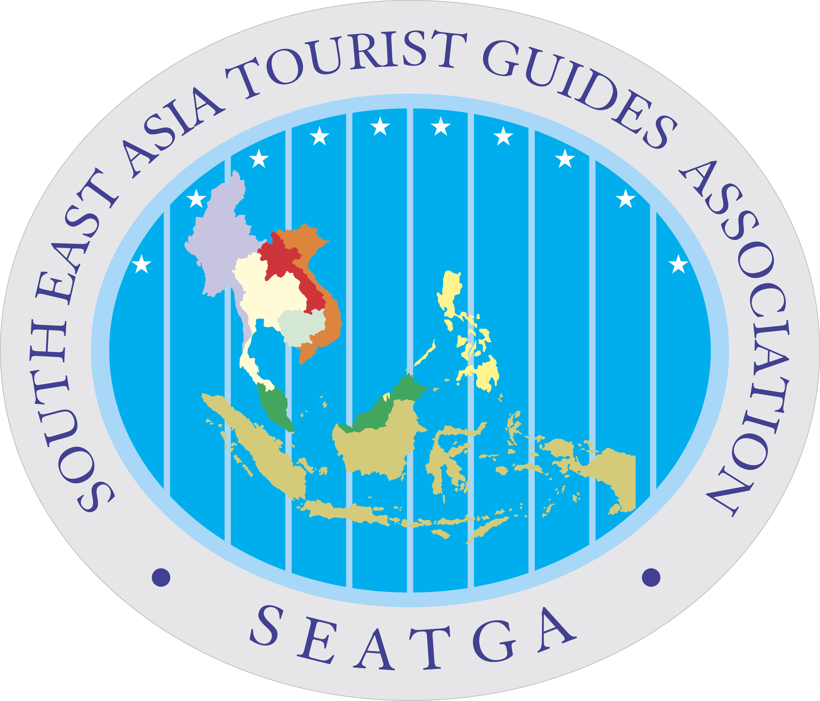

PROGRAM DOCUMENT OVERVIEW

1) Program Title:

National Workshops in 2017

2) Date of Program:

Vietnam workshop in Hanoi - 28 July 2017

3) Venue of Program:

Cambodia, Laos, Myanmar & Vietnam (CLMV)

4) Objectives:

- Give an overview as a guideline for ASEAN Cultural and Heritage Tourism products.

- Promote creativeness among the tour operator and tourism students for Cultural and Heritage tourism products for sustainable tourism development.

- To ensure quality cultural heritage and tourism products and professionalism in CLMV.

5) Sponsoring Body

Sectoral Committee/Main Body:

GIZ

Working Group/Sub-Committee:

SEATGA Institute x ACHT.Expert

Remark:

________________________________________________________________________________
6) Qualification Criteria

Selection from GIZ “s tour operators and tourist guide who specialized in cultural and heritage.

7) Tentative Program: 3 hours

Day | Program | Remark
10 mins  20 mins  30 mins  20 mins  30 mins  40 mins  10mins | Introduction & Welcome  Overview of ACHT  Presentation 1:  Good Approach for Cultural & Heritage tourism products  Q & A  Presentation 2:  Techniques of Product Development  Discussion & TO’s Presentations  Conclusion & feedbacks

_________________________________________________________________________________

8) SEATGA Secretariat Contact

Ms Florance
Email: info@seatga.org

